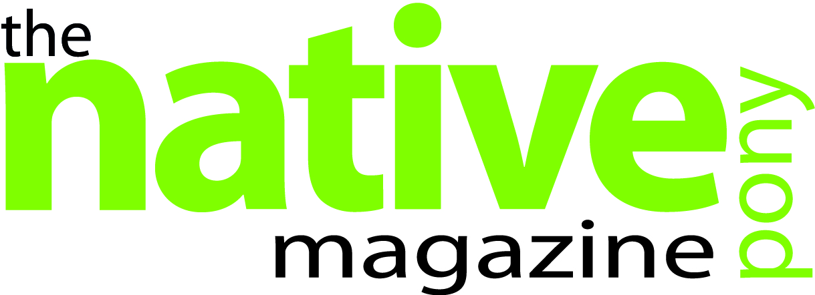

Could you be the Native Pony Magazine sponsored Rider of 2014?
The Native Pony Magazine is offering one of our readers the chance to showcase their enjoyment and demonstrate the versatility of the native breeds, with our eagerly anticipated Sponsorship Package for 2014.
We are looking for applicants to sum up in words and photos, the enjoyment that owning a native pony brings to them, with a chance to win the sponsorship package which includes; nutritional advice from Baileys Horse Feeds and a year’s supply of their recommended feed, consultation from NAF and a support package of supplements, health care and first aid products.
The sponsorship is open to ponies that are on loan, kept at a DIY livery yard or at home and competing in any discipline, but they must be registered mountain and moorlands and you must be able to commit to a year’s sponsorship and importantly the pony needs to be registered with the relevant breed society.
Last year’s winner was Sophie Albery with her New Forest ponies; Wayland Arabesque and Wayland Timberry. Over the year the magazine has supported and followed Sophie as she has competed in showing, dressage, show jumping and cross country at events such as; The New Forest and Hampshire Show and the NAF British Riding Club Championships.
Full details on how to enter can be found in issue 85 which is out now, and an entry form is also available in the upcoming issue 86 on sale from the 16th December. To find out more about the Native Pony Magazine visit www.thenativepony.com.
ENDS
For more information about this press release please contact Margaret Hudd on 01380 734357 or email: margarethudd@redpin.co.uk.
Image is of Sophie Albery 2013 Sponsored Rider.

