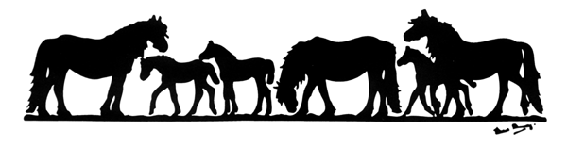
THE FELL PONY SOCIETY

Bank House, Boroughgate, Appleby,
Cumbria, CA16 6XF Patron: His Majesty The King
Tel 017683 53100. Registered Charity No 1104945
Email secretary@fellponysociety.org.uk Company No 3233346

TRANSFER OF OWNERSHIP OF PONY or TRANSFER OF COLT TO GELDING

Transfer of Ownership of Pony

This section of the form must be returned with the passport and fee to The Fell Pony Society (address above) for endorsement, within 30 days of the date of sale. Please complete the form in BLOCK CAPITALS. It is recommended that the passport is sent via a trackable service such as Royal Mail ‘Signed For’ or ‘Tracked’.
FEE: UK: Member £10, Non-Member £20 OVERSEAS: Member £15, Non-Member £25
BACS Account Name:
The Fell Pony Society Sort Code: 30-16-28 Account No: 00254896 (Please use your name as reference)
Name of pony Reg No
If male – colt/stallion/gelding (delete as appropriate). The buyer of an in-foal mare must be given her certificate of service.
Date of Sale
Vendor’s Details (Previous owner) Purchaser’s Details (New owner)
Signature Signature
Name Name
Address Address

Telephone Number Telephone Number
Email Email

Transfer of Colt to Gelding

There is no charge for Transfer to Gelding if the application is made at the same time as Transfer of Ownership.
With effect from 1 January 2025 – if the application is for Transfer to Gelding only:
UK: FPS Member £5, Non member £10. OVERSEAS: FPS Member £10, Non member £15

Name of pony Reg No
I declare that the above pony has now been gelded.

Signed Name (Registered owner)
Address
Date
All personal data will be processed by the Fell Pony Society in accordance with the General Data Protection Regulations 2018. This data will be used for administrative purposes so that the Society can manage its operations effectively. Data may be released to DEFRA and other enforcement bodies to meet the requirements of Equine Identification (England) Regulations 2018. Full details of our privacy policy can be found on our website.
Unless we are advised otherwise your name and address will be recorded in the paper copy of the FPS Stud Book and your name only will be recorded in the Online Stud Book.

Sale Notification

This portion is to be completed, detached and sent by the Vendor (seller) to The Fell Pony Society office at the time of sale.
Please complete the form in BLOCK CAPITALS. The buyer of an in-foal mare must be given her certificate of service.

Name of pony Reg No
I have sold this pony to: Purchaser’s Name Date
Purchaser’s Address

Telephone Number E-mail
Signed Name (Vendor)

