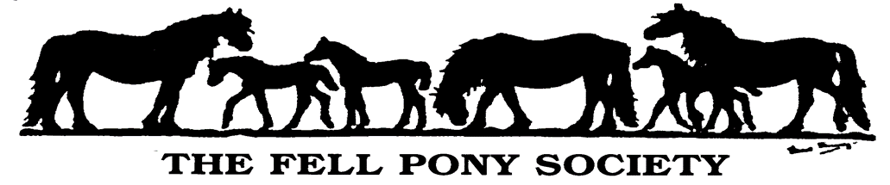

**\*\*\* Congratulations \*\*\***

**You have qualified for The Fell Pony Society**

**2025 Young Handler Championship**

Please confirm your details here:

Name: FPS Membership No:

Area Group:

Show at which you qualified as a Young Handler:

Name of Judge: Date Qualified:

Parent/Guardian

- please sign to confirm the above:

Entry to the Championship is free. There will be a beautiful sash for our Supreme Champion and Reserve, and a Championship rosette for all finalists.

To register that you will be attending the Championship at this year’s Breed Show in August please fill in the details above and email or post a copy to The Fell Pony Society ([secretary@fellponysociety.org.uk](mailto:secretary@fellponysociety.org.uk), Bank House, Boroughgate, Appleby, Cumbria CA16 6XF).

We really hope you can make the trip to the Annual Breed Show to compete in your Championship class.

We appreciate that for some Area Groups, it is a very long way to travel with your pony to the Championship, therefore if you are not able to get your pony to Cumbria, please let us know. We will attempt to find you a pony to enable you to compete in your Championship competition, although we can’t absolutely guarantee we will be able to do so.

***Congratulations on your Qualification***

On the next page is a reminder of the format of the Young Handler Competition.

**Young Handler Competition Rules**

* Area Groups will host the young handler in-hand qualifiers. There can be more than one qualifier in any Area.
* Qualifiers can take place at any event, for example at talks, stud visits, area shows or agricultural shows.
* There are two age categories:

10 years and under (handlers must have attained their 4th birthday but not their 10th birthday before 1st Jan of current year).

* + - * 11 years – 18 years (handlers must have attained their 10th birthday but not their 18th birthday before 1st Jan of current year).
* No colts or stallions to be used. Ponies must be 4 years old and over. Young handlers must wear a conforming hard hat. Adults may accompany children in the 10 years and under class but must not assist unless the handler is in difficulty.
* The top two from each section (who have not already qualified) will attend the Championship at the Breed show.
* You can qualify from 5th August 2024 for the 2025 Breed show. There will be one last qualifier on the morning of the Breed show, open to all Area Groups.
* It is the handler that qualifies, not the pony, so a different pony can be used in the Championship.
* The competition is to be judged on ability of the handler and how they show the pony, not the conformation of the pony.
* In the Championship, only Fell ponies will be used. In qualifying rounds any suitable pony is allowed, in line with these Rules.
* All other FPS rules apply.

***We look forward to seeing you at The Fell Pony Society Breed Show***