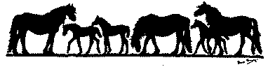

Stallion at Stud

Name of Pony

Registration Number Licence Number

Sire Reg No

Dam Reg No

Year of Birth Colour Height Stud Fee

Name of owner

Address of owner

Contact telephone number

E-mail:

Address where stallion is kept if different from above

Details

Mares will be served in hand YES / NO

Livery is available for mares YES / NO

Mares will run with the stallion YES / NO
Additional information (eg showing, progeny, quiet nature, broken to ride/drive etc.)

There is an annual fee of £30 for non members to place a stallion advertisement on the Stallion at Stud page (w.e.f. 1 April 2019). Completed form, and payment if applicable, should be sent to:
Bank House, Boroughgate, Appleby, Cumbria CA16 6XF
Tel/Fax 017683 53100 Email: secretary@fellponysociety.org.uk

