FPS northern group ride success.

Another successful gathering of Fell Pony enthusiasts in the North area of Scotland was held on Sunday 20th May 2012, organized by area representative Jacqueline Cheetham.

The second Fell Pony Society pleasure ride and picnic at Teindland Trails in Moray was blessed with glorious sunshine. Riders and friends on foot traveled from as far away as Fraserburgh in the East and Dornoch in the West to enjoy a spectacular forest ride before a picnic back at the car park.

The next event in the North is a visit to World Horse Welfare at Aboyne in September. Contact Jacqueline Cheetham on 01346 541250 or email: fellponies@btinternet.com if you are interested in joining in. Details of other events around Scotland can be found on the FPS website.

©.Jacqueline Cheetham. 2012.

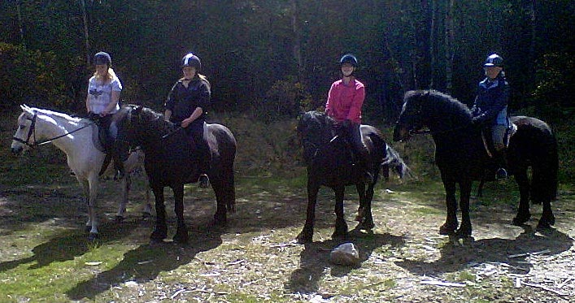
Riders who took part (left to right in photo) Rachel Simpson riding Dino (TB X honorary Fell pony for the day), Anna Simpson riding Mowcop Byron, Jacqueline Cheetham riding Greenholme Kirstie and Jackie Grimshaw riding Inglegarth Mareeno.

