FPS-MESG Spring 2023 Newsletter

After 12 years in the role of Area Coordinator, Kate Merry decided to step down this year and I have taken over. My name is Nic Brierley and I have been involved with the MESG for the past 9 years; joining after buying my Fell Pony Dalewin Kingpin, aka Derek. During that time, I had a stint of producing the Newsletters; I took over organising the Points Awards temporarily until Kayley Radford took over; I currently deal with the Accounts together with Kate as Treasurer which we are both going to continue with and then for the past 5 years, I have been involved in running the Shows at Gotham; which unfortunately I’ve had to step down from this year due to personal circumstances. Thank you to Christine Poole, Bex Leek and the rest of the Show Team for taking over.

2023 Events
Events planned so far within the Area:
Sandringham Show: 16th April
Gotham Shows: 28th May, 9th July & 3rd September. Contact: Christine Poole on 07817 442293 or Bexleek1987@hotmail.com or see our Facebook group page ‘Midlands East Horse & Pony Show’
Southern Show: 10th September, Berkshire College of Agriculture.
Christmas Show: Sunday 10th December, Barton Equestrian Centre, Nottingham NG11 0AA. Contact: Christine Poole on 07817 442293 or Bexleek1987@hotmail.com

For further information on any of these Events, please see our website www.fps-mesg.co.uk or our Facebook Group page ‘Fell Pony Society - Midlands East Support Group’ https://www.facebook.com/groups/Fellponysocietymidlandseast

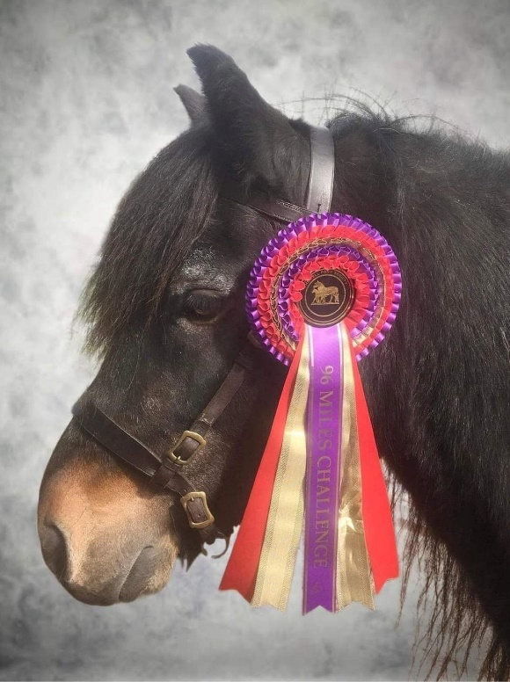
Fell Pony Society 2023 Challenge
The Fell Pony Society would like to keep the spirit of the Centenary Community alive by launching the ‘Queen Elizabeth II Memorial Challenge’. Entrants will be invited to complete 96 miles, one for every year of the late Queen’s life. The start date will be on her Birthday 21st April and will run until 31st October. You must be a member of the Fell Pony Society to be able to take part and this can be completed with a Fell Pony or another breed as long as you are a member. The cost will be £5 to cover the cost of the rosette (as pictured). Miles can be accumulated by riding, driving, leading or long reining and can be done in teams or individually. The Registration and Tracker Forms are available to download from the FPS-MESG Facebook Group page or the Fell Pony Society website 'Challenge' page. The main difference this year, is that Area Groups will be dealing with the Admin side of the Event and Kayley has very kindly offered to do this.

Other events for this year are currently in the pipeline and I urge anyone that has any suggestions or ideas of an event they would like to see organised or if you have an event that you would like to organise yourself, then please feel free to contact me to discuss.

Boy Blue Qualifier
Sadly, the Fell Pony Society has decided to stop the Inter Area Competition, also known as the Boy Blue Qualifier; which took place at the Southern Show each year. The decision has been made, as they thought it had run its course and it ended up with the same ponies competing each year. The Fell Pony Society have said that the Boy Blue Trophy will be reallocated eventually.

Midlands East Centenary Book
Last year for the Centenary year, the Midlands East Area decided to gather material together for a Centenary Book showcasing Fell Ponies from the region over the last 100 years. The book is in the final stages and hopefully will be available to purchase very soon. It will be priced at £7 plus p&p. The cost of production of the book has kindly been covered by sponsorship. The idea is that some of the money raised from the book will be kept by the MESG and the rest will be donated to the Fell Pony Society. Please keep an eye on the website and the Facebook Group page for further information.

Points Awards
Unfortunately last year, the Points Awards was very poorly supported, so we’re going to work hard this year to promote the Awards. Anyone who is a member of the FPS-MESG is eligible to take part. The Points Awards for 2023 began on 1st October 2022 and will finish on 30th September 2023, with the Annual Points Awards celebration in late October/early November 2023. It really is worth ‘having a go’ for the fantastic rosettes ALL competitors receive! Let’s hope there are some newbies having a go this year. All forms are available to download from both the website and the Facebook Group page. Please contact Kayley kayleyradford541@gmail.com if you require any further information.

Website
The MESG does have its own website www.fps-mesg.co.uk which I have been working on updating. I have added a few extra pages such as a page where you can advertise your Fell Ponies For Sale or Loan and a page for Stallion Listings, which is free of charge for all FPS-MESG Members. Also we would love to receive any news you have to be included on the ‘Member’s Gallery’ page especially if it is accompanied by a photograph. In particular it would be good to hear of Fells excelling at activities outside the show ring.

I hope you are all enjoying these lighter nights and are able to get involved in more activities with your ponies, now that we’ve had some drier days!

Nic Brierley
FPS-MESG Area Coordinator
nicshortland@yahoo.com

Contacts
Area Coordinator: Nic Brierley nicshortland@yahoo.com
Treasurer and Accounts: Kate Merry bkmerry@gmail.com and Nic Brierley
Performance Awards: Kayley Radford kayleyradford541@gmail.com
Membership Secretary: Janet Copeland 07973620191 copeson@hotmail.co.uk

Essex and Suffolk
Julia Baldwin 07766395779
Jo Whitelaw 01473 832734

Hertfordshire and Bedfordshire
Currently vacant - please contact nicshortland@yahoo.com if you are able to help

Norfolk
Jean Bateson jean1058@outlook.com
Lisa Dunger 01485 298327

Northamptonshire
Kate Merry 01788 823215 bkmerry@gmail.com

Nottinghamshire, Leicestershire and Rutland
Janet Copeland 07973 620191

Oxfordshire
Currently vacant - please contact nicshortland@yahoo.com if you are able to help

Lincolnshire
Nikki Ash 07771 590938

Cambridgeshire
Rachael Nicholls 07827 727678 kernow_witch@hotmail.com

Buckinghamshire
Tabitha Bennet 07969 003724

