CUMBRIA FELL AND DALES
PONY SHOW

RESULTS

SATURDAY 9th JUNE 2012, 9.00 am START

CLASSES
FELL PONY IN HAND CLASSES – Judge: Mrs Glenis Cockbain, Keswick Cumbria
1. Yearling Colt, Filly or Gelding
1ST 218 Banksgate Bronco Mr A Ashcroft
2ND 247 Deepghyll Lucky Touch Miss C Savage
3RD 245 Lunesdale Dan Mathews Mr AW Morland
4TH 263 Lownthwaite Hot Gossip Miss R Gibbs
5TH 201 Lownthwaite Lotto Mrs C Wrigley
6TH 264 Darrenvale Chancer Miss C Read

2. Two Year Old Filly or Gelding
1ST 229 Drummersdale Limited Edition Mrs E Pringle
2ND 223 Auckside Joe Mr A Summerbell
3RD 239 Bybeck Lady Diana Mrs G Rae
4TH 206 Murthwaite Storm Mrs N Lovegreen
5TH 244 Brackenthwaite Josie Mrs R Douglas
6TH 216 Thornbeck Andrew Miss V Parker

3. Three Year Old Filly or Gelding

1ST 240 Bracklinn Melissa Mrs G Rae
2ND 248 Muthwaite Prime Suspect Miss C Savage
3RD 232 Haweswater Firecracker Mrs C Jones
4TH 227 Murthwaite Tonka Toy Amanda Batey

4. Gelding, 4 years and over
1st 249 Murthwaite Sako .308 Miss C Savage
2nd 204 Tynebank Danny Boy Mr D Parkinson
3rd 215 Castle Hill Jo Mrs L Reeday
4th 207 Murthwaite Warrior Mrs N Lovegreen

5. Mares, without foal at foot, 4 years and over
1st 203 Towford Harmarnie Mr A Anderson
2nd 267 Murthwaite Dawn Chorus Miss C Savage
3rd 230 Lunesdale Mountain Music Miss E Empsall
4th 228 Hillhead Emma II Mrs H Gallagher
5th 235 Bybeck Cherry Blossom Mrs J Coates
6th 252 Lownthwaite Fingerprint Miss A Morton

6. Mare, with foal at foot

1st 236 Lunesdale Limelight Mr J M Rawlinson

7. Foal, to be at least 3 weeks old on show day and eligible for FPS registration.

1st 237 Thornbeck Foal Mr J M Rawlinson

8. Veteran Pony, 16 years and over (stallions excluded)

NO ENTRIES

9. NPS/Area 25 Home Produced M&M In Hand Championship
1ST 229 Drummersdale Limited Edition Mrs E Pringle
2ND 223 Auckside Joe Mr A Summerbell
3RD 228 Hillhead Emma II Mrs H Gallagher
4TH 235 Bybeck Cherry Blossom Mrs J Coates
5TH 262 Kerbeck Odin’s Fire Miss G Hunter

6TH 227 Murthwaite Tonka Toy Mrs A Batey

FELL PONY IN HAND CHAMPIONSHIP 1st and 2nd prize winners from classes 1-9 to compete
203 Towford Harmarnie Mr A Anderson champ
218 Banksgate Bronco Mr A Ashcroft res

FELL PONY YOUNGSTOCK IN HAND CHAMPIONSHIP 1st and 2nd prize winners from classes 1, 2, 3 AND 7 to compete
218 Banksgate Bronco Mr A Ashcroft champ
229 Drummersdale Ltd. Edition E. Pringle res

FELL PONY OVERALL SUPREME CHAMPION. Ridden, In Hand and WHP Champions and Reserves to compete

203 Towford Harmarnie Mr A Anderson
257 Severnvale Grey Bobby Miss A Robinson (reserve)

FELL PONY RIDDEN CLASSES COMMENCING WITH RIDDEN NPS QUALIFIERS
Judge: Miss D Chadwick, Preston Lancashire

10. The NPS/Picton M&M Novice Fell Ridden
1st 215 Castle Hill Jo Mrs L Reeday
2nd 254 Lunesdale Warrior Queen Miss A Robinson
3rd 273 Rundales Mayfly Charlotte Miller
4th 213 Dene Decoris Miss S Pringle

11. The NPS/Peasedown Stud M&M Intermediate Fell Ridden
1st 249 Murthwaite Sako .308 Miss C Savage
2nd 262 Kerbeck Odin’s Fire Miss G Hunter

3rd 273 Rundales Mayfly Charlotte Miller
4th 213 Dene Decoris Miss S Pringle
5th 271 Linnel Fern Georgia Norfolk

12. The NPS/Ringside Stud M&M Open Fell Ridden

1st 257 Severnvale Grey Bobby Miss A Robinson
2nd 255 Lunesdale Aurora Mrs J Robinson
3rd 262 Kerbeck Odin’s Fire Miss G Hunter

4th 231 Brackenbank Bobby Miss H Waterhouse
5th 226 Bybeck Ebony Miss A Nowell

13. The NPS/R H R Demolition Ltd M&M Junior Fell Ridden

1st 231 Brackenbank Bobby Miss H Waterhouse
2nd 254 Lunesdale Warrior Queen Miss A Robinson
3rd 214 Bracklinn Bertie Miss S Braithwaite

4th 226 Bybeck Ebony Miss A Nowell
5th 225 Orton Hall Dusky Miss E Exley

14. The NPS/Dargavel M&M Young Open Ridden Fell Pony

1st 255 Lunesdale Aurora Mrs J Robinson
2nd 215 Castle Hill Jo Mrs L Reeday

3rd 273 Rundales Mayfly Charlotte Miller

15. Novice Pony in its first season under saddle Snaffle bridles only. (stallions excluded)

1st 215 Castle Hill Jo Mrs L Reeday

2nd 273 Rundales Mayfly Charlotte Miller
3rd 250 Wansfell Sheena Mrs J Reekie
4th 253 Dalewin Liberty Miss B Dent
5th 268 Townend Dream Mrs P Randell
6th 217 Broxdown Barracus Mrs A Ferrier

16. Novice Pony Not to have won 2 firsts in ridden classes. Any suitable bit. (stallions excluded)

1st 267 Murthwaite Dawn Chorus Miss C Savage
2nd 253 Dalewin Liberty Miss B Dent
3rd 250 Wansfell Sheena Mrs J Reekie
4th 217 Broxdown Barracus Mrs A Ferrier
5th 213 Dene Decoris Miss S Pringle
6th 272 Aukside Dancer Richard Lee

17. Traditional Ridden. Walk and Trot only

1st 249 Murthwaite Sako .308 Miss C Savage
2nd 273 Rundales Mayfly Charlotte Miller

3rd 269 Townend Eden Mrs P Randell
4th 262 Kerbeck Odin’s Fire Miss G Hunter
5th 214 Bracklinn Bertie Miss S Baithwaite
6th 213 Dene Decoris Miss S Pringle

- Veteran Pony under saddle. Pony to be 16 years and over.

1st 225 Orton Hall Dusky Miss E Exley
2nd 251 Llancloudy Zap Mrs J Reekie

FELL RIDDEN CHAMPIONSHIP 1st and 2nd prize winners from classes 10 - 18 to compete
257 Severnvale Grey Bobby Miss A Robinson
249 Murthwaite Sako .308 Miss C Savage (reserve)

YOUNG RIDER/HANDLER AND BEST TURNED OUT
Judge: Miss Carly Glasper Bishop Auckland Co. Durham

19. Best Turned Out (see schedule timetable) (stallions excluded)
1st 202 Lownthwaite Inara Mrs C Wrigley

20. Young Handler (Handler to be 16 years or under as of 1st January 2012. Hard Hats to be worn) (stallions excluded) All entries to receive a rosette.
NO ENTRIES

21. Young Rider (Rider to be 16 years or under as of 1st January 2012) (stallions excluded)
All entries to receive a rosette.
1st 214 Bracklinn Bertie Miss S Braithwaite

OVERALL JUNIOR BEST RIDER CHAMPIONSHIP, 1ST AND 2ND PRIZE WINNERS OF CLASSES 13, 21, 43 & 51 TO COMPETE
214 Bracklinn Bertie Miss S Braithwaite

FELL PONY PLEASURE DRIVING (TO BE JUDGED WITH THE DALES DRIVING)
Judge: Mr Rodger James Rugeley Staffordshire
21. Any Vehicle to be judged with class 52 in Ring, followed by show drive

1st 204 Tynebank Danny Boy Mrs J Parkinson
Tynebank Brown Bobby

2nd 252 Lownthwaite Finger Print Miss A Morton

FELL PONY WORKING HUNTER Judge: Mr Rodger James Rugeley Staffordshire
23. The NPS/Area 25 M&M Working Hunter Pony National Championship
1st 265 Carrock Stormbreaker Miss C Read

2nd 224 Raisbeck Casino Miss E Exley

24. The NPS/KBIS M&M Intermediate Working Hunter Pony National Championship
1st 224 Raisbeck Casino Miss E Exley
2nd 265 Carrock Stormbreaker Miss C Read

3rd 234 Kerbeck Smugglers Fire Miss Z Brain

25. The NPS/Leyhills M&M Working Hunter Pony Starter Stakes National Championship
1st 217 Broxdown Barracus Miss A Cussons
2nd 213 Dene Decoris Miss S Pringle

26. The NPS/Mrs M Alford’s M&M Junior Working Hunter Pony National Championship

1st 224 Raisbeck Casino Miss E Exley
2nd 234 Kerbeck Smugglers Fire Miss Z Brain

27. Pony not to have ever entered a WHP class before, jumps set at max 30cm.

1st 215 Castle Hill Jo Mrs L Reeday
2nd 269 Townend Eden Mrs P Randell
3rd 271 Linnel Fern Georgia Norfolk
4th 225 Orton Hall Dusky Miss E Exley

28. Novice WHP not to have won a WHP class. Fences, not to exceed 55cm.

1st 213 Dene Decoris Miss S Pringle
2nd 217 Broxdown Barracus Miss A Cussons
3rd 271 Linnel Fern Georgia Norfolk

29. Junior Working Hunter Fences Not To Exceed 60cm Rider to be 16 years or under as of 1st January 2012) (stallions excluded)
1st 224 Raisbeck Casino Miss E Exley

30. Open WHP Fences Not To Exceed 75cm
1st 224 Raisbeck Casino Miss E Exley

FELL PONY CHAMPION WORKING HUNTER PONY, 1ST AND 2ND PRIZE WINNERS OF CLASSES 23 TO 30 TO COMPETE
224 Raisbeck Casino Miss E Exley

DALES PONY IN HAND CLASSES Judge: Mrs Emma Heywood West Auckland Co. Durham

31. Yearling Colt, Filly or Gelding

1st 246 Morlandsdale Master A & W Morland
2nd 131 Nipna Impatiens Mrs Jean Knowles

32. Two Year old Filly or Gelding

1st 137 Castle Hill Stella Claire Crow
2nd 126 Lowhouses Monica R & F Longstaff
3rd 109 Roandale Dora Charlie Parker
4th 132 Nipna HollyHock Mrs Jean Knowles

5th 118 Pennybrook Merlin Helen Robinson

33. Three Year old Filly or Gelding

1st 105 Carrock Daisy Mr & Mrs J Cockbain
2nd 119 Pennybrook Ebony Rose Helen Robinson
3rd 134 Kebroyd Royal Sapphire Mr I Graham
4th 114 Griseburn Empress Mrs H A Horn
5th 124 Langrigg John Claire Savins

34. Gelding, 4 Years and over

1st 123 Tudor Chancer Mr J Alderson and Mrs A Smith
2nd 128 Larumgill Michael Brian Lund

3rd 110 Roandale Rock Charlie Parker
4th 143 Thornville Luke B. Walton
35. Mares, without foal at foot, 4 years and over

1st 121 Thornville Jenna Mr & Mrs T&J Sharp
2nd 135 Colliery Beauty II Mr I Graham
3rd 127 Lowhouses Rebecca R & F Longstaff
4th 133 Waterside Princess II S Hird
5th 111 Roandale Clever Girl Charlie Parker
6th 113 Griseburn Black Darcy Mrs H A Horn

36. Mare, with foal at foot
1st 106 Carrock Sally Mr & Mrs J Cockbain

37. Foal, to be at least 3 weeks old on show day and eligible for DPS registration.
1st 107 Carrock Filly Mr & Mrs J Cockbain

38. Veteran Pony, 16 years and over (stallions excluded)
1st 136 Keasbeck Daffodil Mr I Graham

39. NPS/Area 25 Home Produced M&M In Hand Championship
1st 121 Thornville Jenna Mr & Mrs T&J Sharp
2nd 126 Lowhouses Monica R & F Longstaff
3rd 127 Lowhouses Rebecca R & F Longstaff
4th 123 Tudor Chancer Mr J Alderson and Mrs A Smith
5th 130 Manorian Marshall Samantha Hamilton

DALES YOUNGSTOCK IN HAND CHAMPIONSHIP 1st and 2nd prize winners from classes 31, 32, 33 AND 37 to compete
137 Castle Hill Stella Claire Crow
105 Carrock Daisy Mr & Mrs J Cockbain (reserve)

DALES IN HAND CHAMPIONSHIP 1st and 2nd prize winners from classes 31-39 to compete
121 Thornville Jenna Mr & Mrs T&J Sharp
137 Castlehill Stella Claire Crow (res)

DALES PONY OVERALL SUPREME CHAMPION. Ridden, In Hand and WHP Champions and Reserves to compete
121 Thornville Jenna Mr & Mrs T&J Sharp
135 Colliery Beauty II Mr I Graham Rider B.Williams(reserve)

DALES PONY RIDDEN CLASSES Judge: Mrs Carol Glasper, Bishop Auckland Co. Durham

40. The NPS/Picton M&M Novice Dales Ridden

1st 135 Colliery Beauty II Mr I Graham Rider B.Williams

2nd 130 Manorian Marshall Samantha Hamilton
3rd 108 Lowhouses Jemima Jill Gillthorpe
4th 140 Westwick Smartie Mrs J & Miss E Wade Rider E. Wade
5th 138 Castle Hill Lilly Claire Crow Rider Clair Thomlinson Ellis

41. The NPS/Peasedown Stud M&M Intermediate Dales Ridden

1st 112 Wheatridge Midnight Amanda Wallace
2nd 104 Kebroyd Onyx B Williams Rider B Williams
3rd 144 Colliery Bill II Nicola Eminson
4th 115 Westwick Johnny Jill Fearnhead

42. The NPS/Ringside Stud M&M Open Dales Ridden

1st 104 Kebroyd Onyx B Williams Rider B. Williams
2nd 112 Wheatridge Midnight Amanda Wallace
3rd 144 Colliery Bill II Nicola Eminson
4th 115 Westwick Johnny Jill Fearnhead

43. The NPS/R H R Demolition Ltd M&M Junior Dales Ridden
1st 140 Westwick Smartie Mrs J & Miss E Wade Rider E. Wade

44. The NPS/Dargavel M&M Young Open Ridden Dales Pony
1st 130 Manorian Marshall Samantha Hamilton
2nd 104 Kebroyd Onyx B Williams Rider B Williams
3rd 123 Tudor Chancer Mr J Alderson and Mrs A Smith Rider Mrs A Smith

45. Novice Pony in its first season under saddle Snaffle bridles only. (stallions excluded)
1st 145 Maidendale Waltzing Matilda Nicola Eminson

46. Novice Pony Not to have won 2 firsts in ridden classes. Any suitable bit. (stallions excluded)

1st 145 Maidendale Waltzing Matilda Nicola Eminson

2nd 140 Westwick Smartie Mrs J & Miss E Wade Rider E. Wade
3rd 108 Lowhouses Jemima Jill Gillthorpe

47. Traditional Ridden. Walk and Trot only

1st 112 Wheatridge Midnight Amanda Wallace
2nd 108 Lowhouses Jemima Jill Gillthorpe
3rd 115 Westwick Johnny Jill Fearnhead
4th 144 Colliery Bill II Nicola Eminson
5th 123 Tudor Chancer Mr J Alderson and Mrs A Smith Rider Mrs A Smith
6th 143 Thornville Luke Abbie Walton

48. Veteran Pony under saddle. Pony to be 16 years and over.
1st 136 Keasbeck Daffodil Mr I Graham Rider Mrs J Graham

DALES RIDDEN CHAMPIONSHIP 1st and 2nd prize winners from classes 40 - 48 to compete

112 Wheatridge Midnight Amanda Wallace (champ)
135 Colliery Beauty II Mr I Graham Rider B.Williams (res)

YOUNG RIDER/HANDLER AND BEST TURNED OUT
Judge: Miss Carly Glasper Bishop Auckland Co. Durham

49. Best Turned Out (see schedule timetable) (stallions excluded)
1st 127 Lowhouses Rebecca R & F Longstaff Handler Olivia Stones
2nd 119 Pennybrook Ebony Rose Helen Robinson Handler Emma Robinson

50. Young Handler (Handler to be 16 years or under as of 1st January 2012. Hard Hats to be worn)
(stallions excluded) All entries to receive a rosette.
1st 143 Thornville Luke Abbie Walton
2nd 127 Lowhouses Rebecca R & F Longstaff
3rd 140 Westwick Smartie Mrs J & Miss E Wade Hndlr E. Wade
4th 119 Pennybrook Ebony Rose Helen Robinson Hndlr Emma Robinson

51. Young Rider (Rider to be 16 years or under as of 1st January 2012) (stallions excluded)
All entries to receive a rosette.
1st 140 Westwick Smartie Mrs J & Miss E Wade Rider E. Wade
2nd 143 Thornville Luke Abbie Walton

OVERALL JUNIOR YOUNG HANDLER CHAMPIONSHIP 1ST AND 2ND PRIZE WINNERS OF CLASSES 50 AND 20 TO COMPETE
143 Thornville Luke Abbie Walton
127 Lowhouses Rebecca R & F Longstaff Reserve)

DALES PONY PLEASURE DRIVING (TO BE JUDGED WITH FELL PONY DRIVING)
Judge: Mr Rodger James Rugeley Staffordshire

52. Any Vehicle – to be judged with class 22 in Ring, followed by show drive.
1st 128 Larumgill Michael Brian Lund

DALES PONY WORKING HUNTER
Judge: Mr Rodger James Rugeley Staffordshire

53. The NPS/Area 25 M&M Working Hunter Pony National Championship
NO ENTRIES

54. The NPS/KBIS M&M Intermediate Working Hunter Pony National Championship
NO ENTRIES

55. The NPS/Leyhills M&M Working Hunter Pony Starter Stakes National Championship

NO ENTRIES
56. The NPS/Mrs M Alford’s M&M Junior Working Hunter Pony National Championship

NO ENTRIES

57. Pony not to have ever entered a WHP class before, jumps set at max 30cm.

1ST 115 Westwick Johnny Jill Fearnhead

58. Novice WHP not to have won a WHP class. Fences, not to exceed 55cm.
NO ENTRIES

59. Junior Working Hunter Fences Not To Exceed 60cm Rider to be 16 years or under as of 1st January 2012
NO ENTRIES

60. Open WHP Fences Not To Exceed 75cm
NO ENTRIES

DALES PONY CHAMPION WORKING HUNTER PONY, 1ST AND 2ND PRIZE WINNERS OF CLASSES 53 TO 60 TO COMPETE
115 Westwick Johnny Jill Fearnhead

DALES PONY OVERALL SUPREME CHAMPION. Ridden, In Hand and WHP Champions and Reserves to compete

FELL AND DALES PONIES
BEST SHOD (To present to judge between 10am and 12noon)
Judge: Mr Rodger James Rugeley Staffordshire

61. Fell Pony
2ND 226 Bybeck Ebony Miss A Nowell
1ST 230 Lunesdale Mountain Music Miss E Empsalll

62. Dales Pony
1ST 123 Tudor Chancer Mr J Alderson and Mrs A Smith

A trophy is awarded to the Best Shod Pony from Classes 61 and 62 No.230
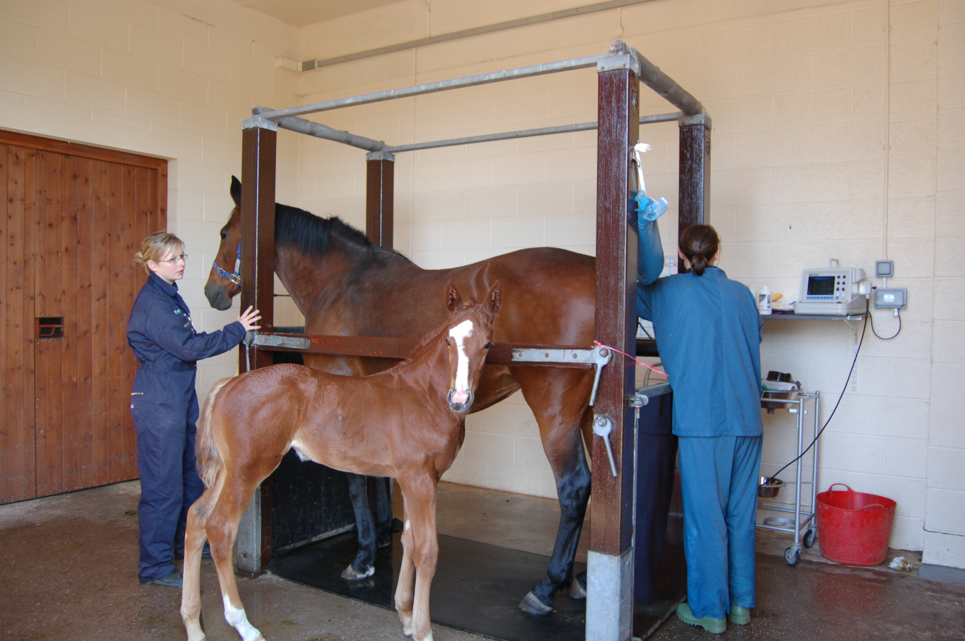
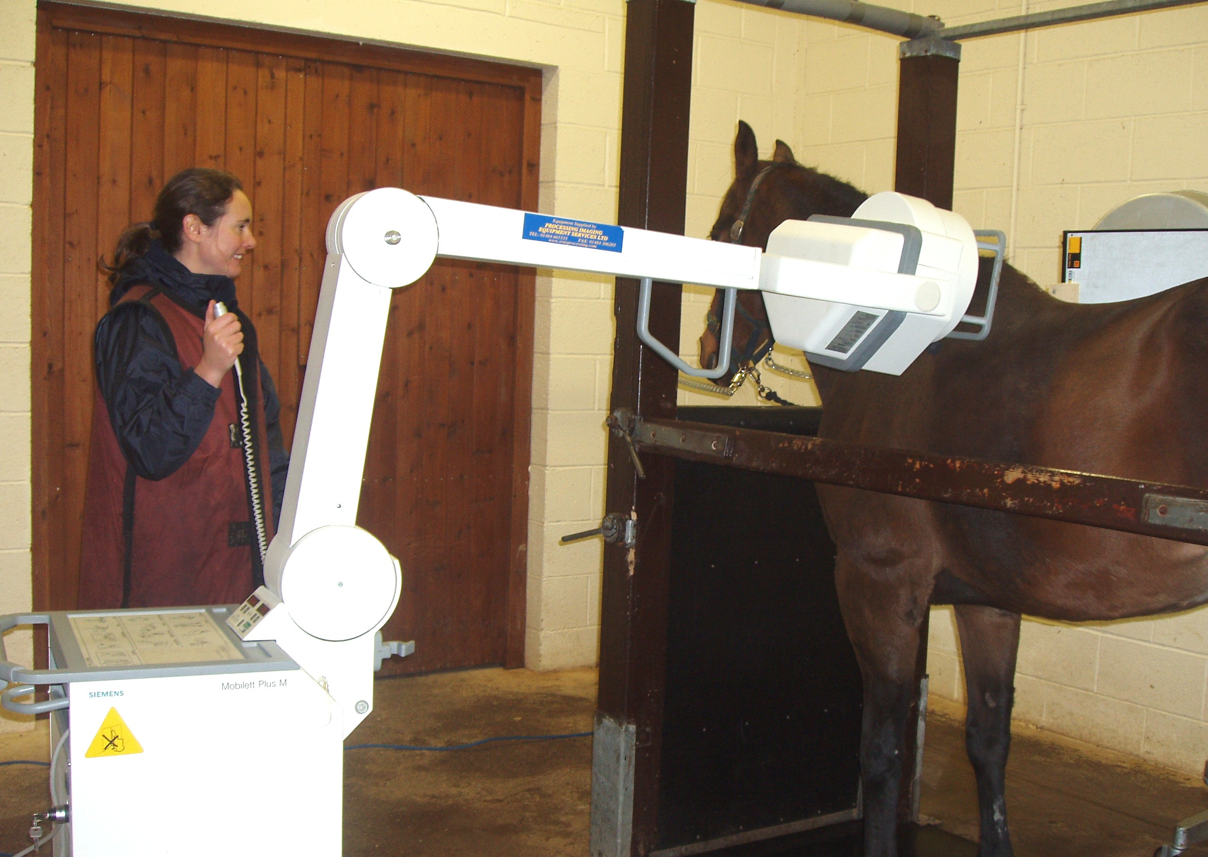

Lameness
Investigations

Stables
Paddocks
Artificial
Insemination
Carlisle House, Townhead Road
Dalston, Carlisle, CA5 7JF
PARAGON VETERINARY GROUP
A complete range of veterinary services including Farm, Equine, Pets, Exotics, Grooming and
Advanced Breeding Services
www.paragonvet.com
Theatre
Digital
Radiography &
Ultrasound
Scanner
Townhead Farm, Newbiggin
Penrith, Cumbria CA11 0HT
Telephone: 017684 83789

