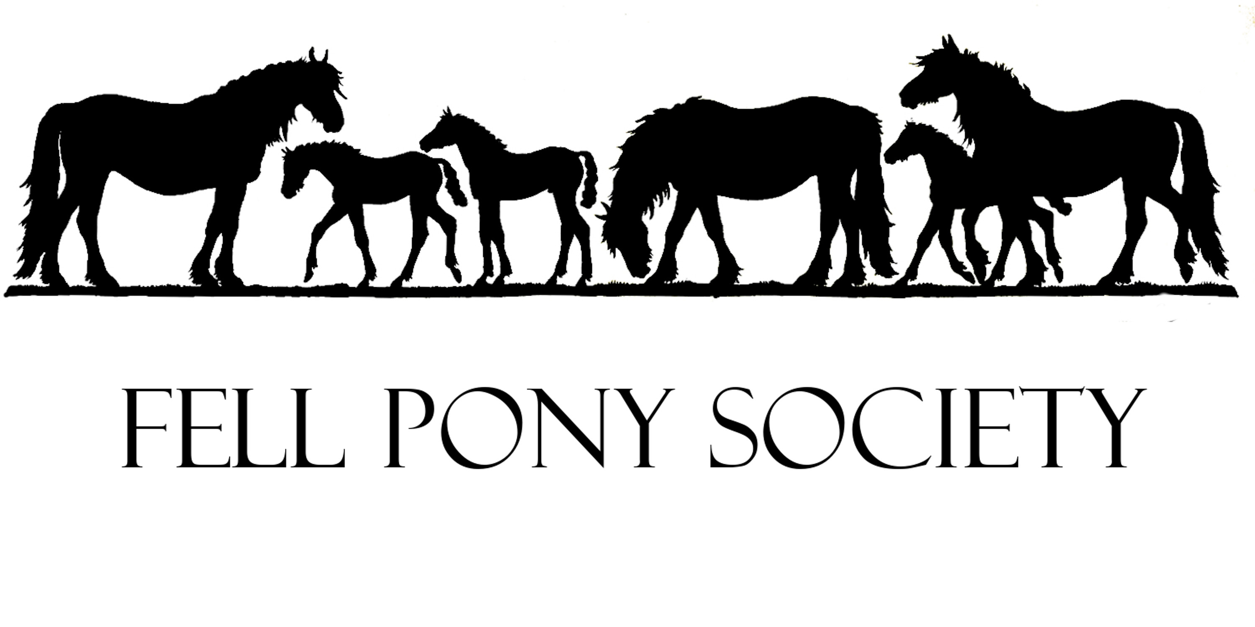
Patron: His Majesty King Charles III
Founded 1922.
Registered Charity, Number 1104945.
The Fell Pony Society is a Company Limited by Guarantee 3233346.
https://www.fellponysociety.org.uk

Scan this QR Code to go to the FPS website.
The Fell Pony Society can answer most questions you want to ask about the Fell Pony Breed.

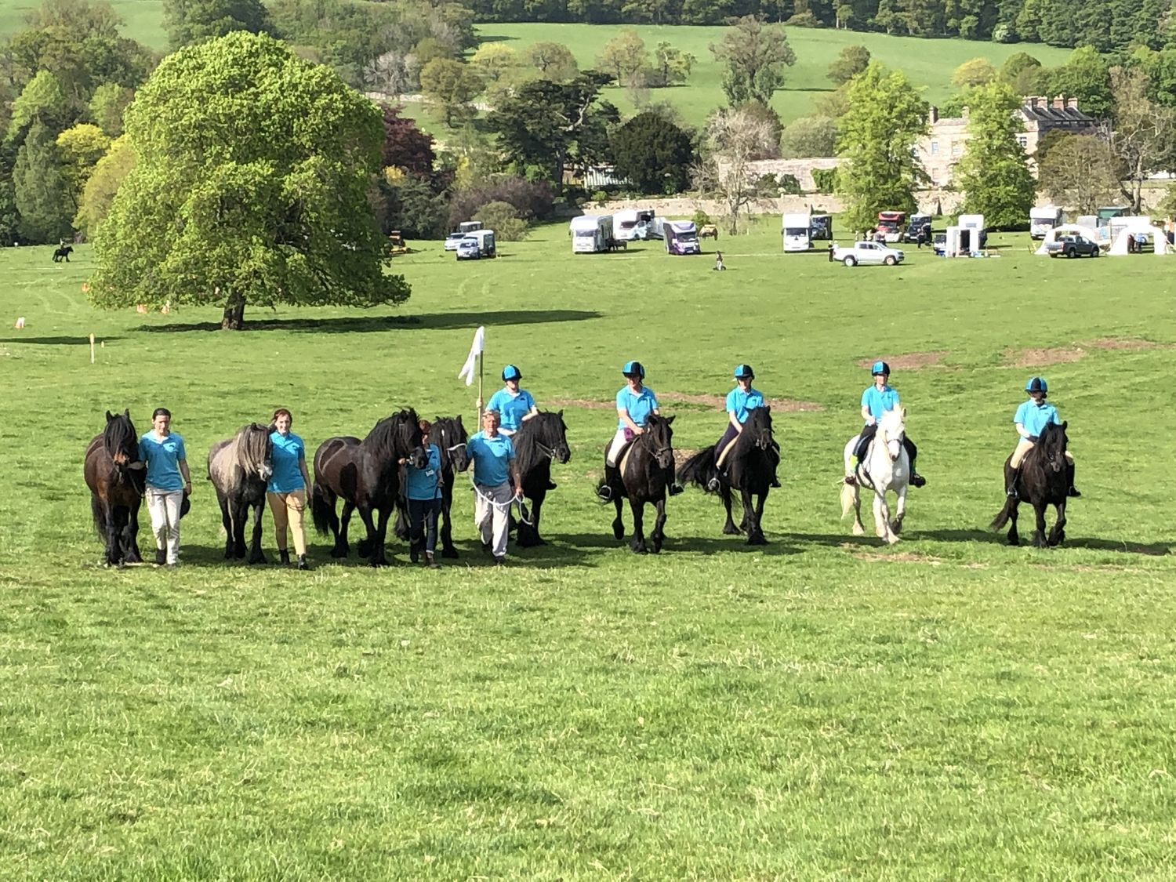

- The Fell Pony Society's aim is to foster and keep pure the old breed of pony which has roamed the northern fells for years and to circulate knowledge and general information about the pony breed.
Below are the ways in which it does this:
- The Society has been looking after the Fell pony breed for over 100 years. It was officially formed in 1922, but was active for a decade before that as the Northern Fell Pony Committee.
- The FPS has the King as its Patron, following the late Queen who was Patron for 40 years.
- The FPS is a Charity since 2004 and a Limited Company since 1996. Annual accounts are published in the FPS Magazine, and on the Charity Commission web site and the Companies House web site.
- The FPS Council has a President, and 20 voting members who are Directors of the Ltd Company and Trustees of the Charity, including Chairman and Vice Chairman; plus a paid Secretary and 2 office staff.
- The FPS has a UK and international membership of more than 1,000, including USA, Netherlands, France, Germany, Denmark, Sweden, Norway, Switzerland, Russia and Czech Republic. It has UK Area Support Groups, and Overseas Daughter Societies and Branches. It serves ALL Fell pony breeders, owners and enthusiasts, from single pony owners and junior members to hill-herd breeders and everything in between.
- The Society is the only Passport Issuing Organisation for the breed. It is responsible for correct paperwork for all registered Fell ponies (this is checked by the Dept for Trading Standards). The FPS owns all Fell pony passports. It deals with the Registration of Ponies as foals, and the Transfers of Ownership when ponies are sold on.
- The FPS publishes an annual Stud Book and maintains the database of registered ponies (Grassroots).
- The FPS issues Stallion licenses, issues AI permits, and confirms parentage, including test kits for DNA sampling.
- The FPS supplies anonymised data to the Rare Breeds Survival Trust which informs their Watch List of At Risk Breeds.
- The FPS works with the RBST to obtain and store semen from Fell stallions for future use via AI.
- The FPS works to ensure the health of the ponies, eg the FIS research over 15 years which resulted in an accurate FIS test in 2010; it supplies test kits to breeders to check FIS status.
- The FPS has a web site. Minutes of Council meetings can be seen on the relevant page. It has a presence on Facebook and other social media.
https://www.fellponysociety.org.uk
Scan this QR Code to go to the FPS website:
- The FPS informs members about new legislation, eg to comply with DEFRA health & paperwork regulations.
- The FPS handles most export matters regarding Fell ponies and grapples with the admin problems of registering EU born foals post-Brexit (very complicated).
- The FPS receives and distributes the £8,000+ annual grant from the Horserace Betting Levy Board, which funds Performance awards and Youngstock Premiums for all owners and breeders.
- The FPS produces two Magazines per year and has a Press officer putting material into local and nationwide publications.
- FPS argued to get the Fell pony recognised as a heritage breed for the Lake District World Heritage Site (2017). Members also work with national and local organisations and estates (eg, Fix the Fells, Friends of the Lake District, Friends of Ullswater Way etc etc) to keep the ponies in the public eye.
- The FPS handles publicity, media and general requests for information, text and photographs about Fells; it has an extensive archive of historic photographic and other material plus an archive in County Records Office in Kendal.
- The FPS advertises lists of members’ ponies for sale and stallions at public stud and runs an annual Sale of Ponies in the autumn.
- The FPS runs several major Breed shows – the Stallion & Colt Show, South Cumbria Show, Breed Show, Southern Show, Foal & Youngstock Show.
- The FPS accepts Affiliations from, and supplies rosettes to, shows in the UK and overseas who run showing classes under FPS rules with FPS panel judges.
- The FPS trains judges, publishes a list of FPS Panel judges, and arranges regular Probationer training for prospective judges throughout the showing season.
- The FPS gives trophies and awards annually to owners of Fell ponies in many different disciplines.
- The FPS advertises a regular calendar of Fell pony events throughout Great Britain, as well as a non-competitive "Challenge" to include people who do not show.
- The FPS produces educational material
  - such as videos to educate judges and owners
  - on the FPS web site, health advice and links to useful sites about native pony health
- The FPS has various sub committees to help owners and breeders:
  - Show sub committee running breed shows
  - Judges sub committee training probationers and approving them as new judges
  - Display Team sub committee organising the public display of Fell ponies done at non FPS Shows, and the Display Team stand
  - The Conservation & Grazing sub committee to help people find ponies and advice for environmental work
- The FPS runs a Learning With Fells programme, free to all members and with a travel bursary available, to enable them to learn more about the Fell pony breed, its traditional habitat and management.
- The FPS sells FPS branded and Fell themed merchandise and educational books about the Fell pony breed.
- The FPS has a Display Team that gives Fell Ponies a public presence at country shows by performing musical rides and pageants with commentary, including a publicity stand, that also attends other shows during the year.
- FPS Council members are involved in Heritage, Arts and Education projects such as the Epona Landscape Art project in the Lune Gorge and have been involved with other work with Westmorland Dales such as the “Our Common Heritage” interviews with Fell pony stud owners.
- The FPS can provide talks about Fell ponies, and “pony visits” led by enthusiasts who go to schools with a pony to talk to students about Fells.
- The Fell Pony Society can answer most questions you want to ask about the Fell Pony Breed.

