Check Mate – Grassroots Pedigree Database
Click on the menu top right. Select Check Mate to find common ancestors in a potential mating. | 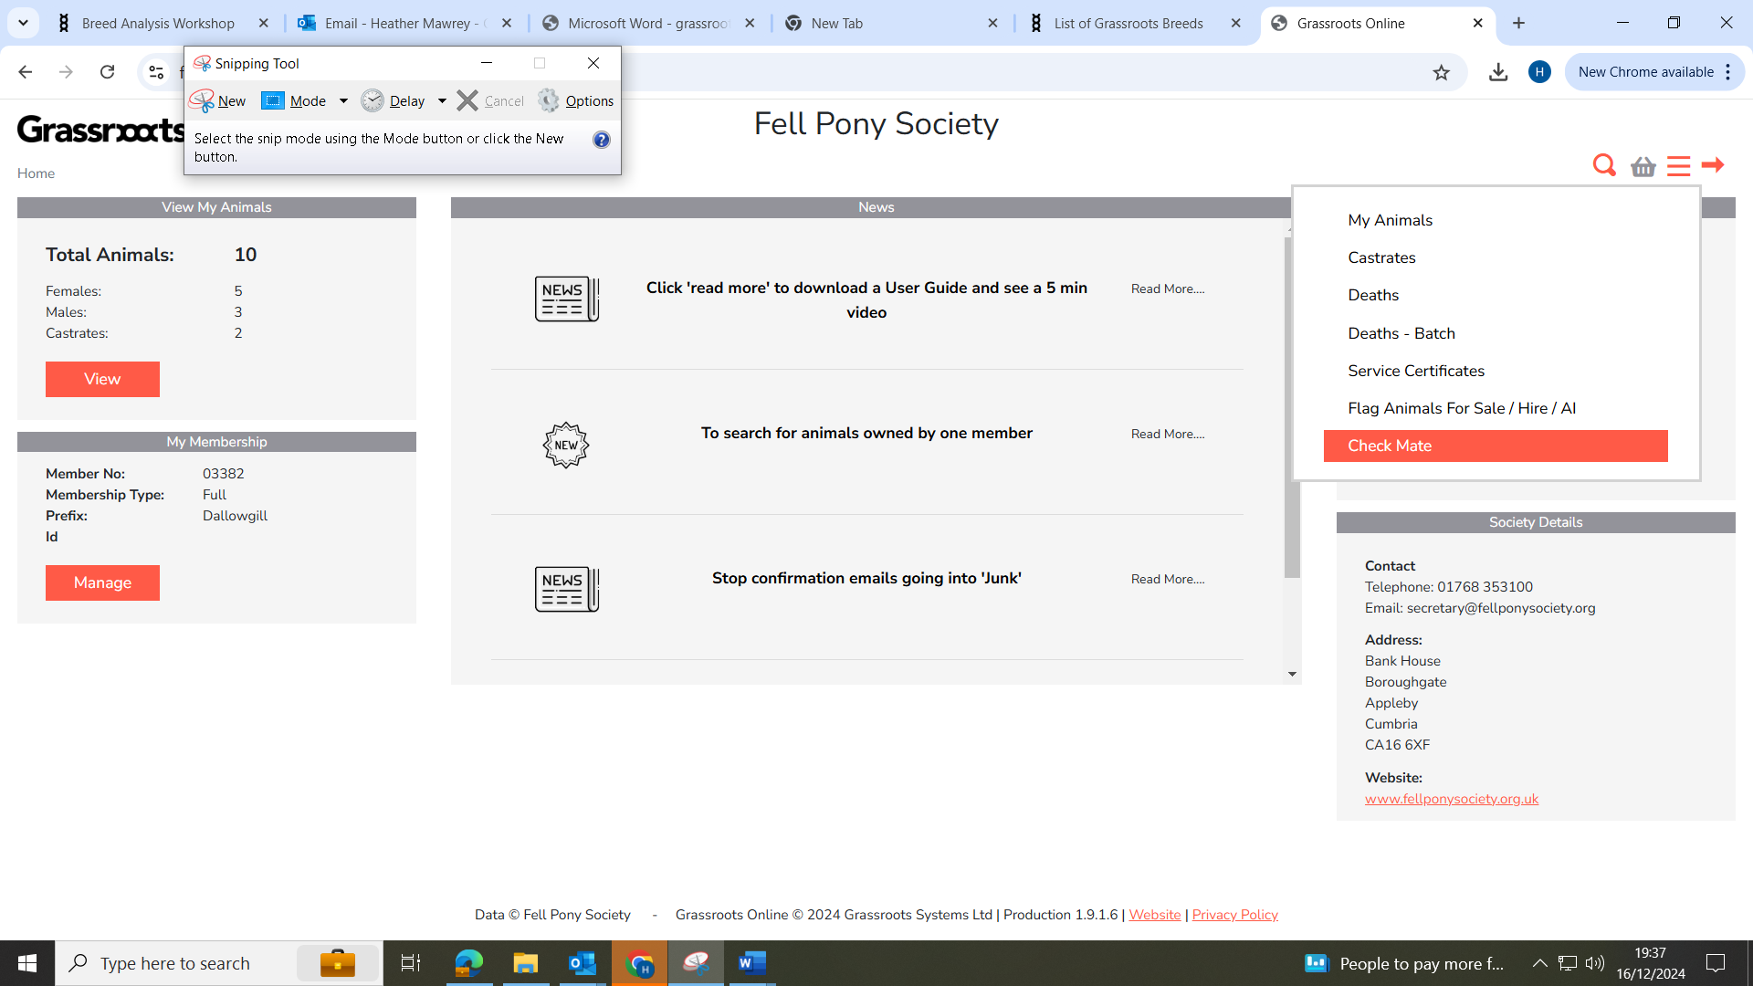
Click on Search for male and type in part of the name or number. Select the animal from the list offered. | 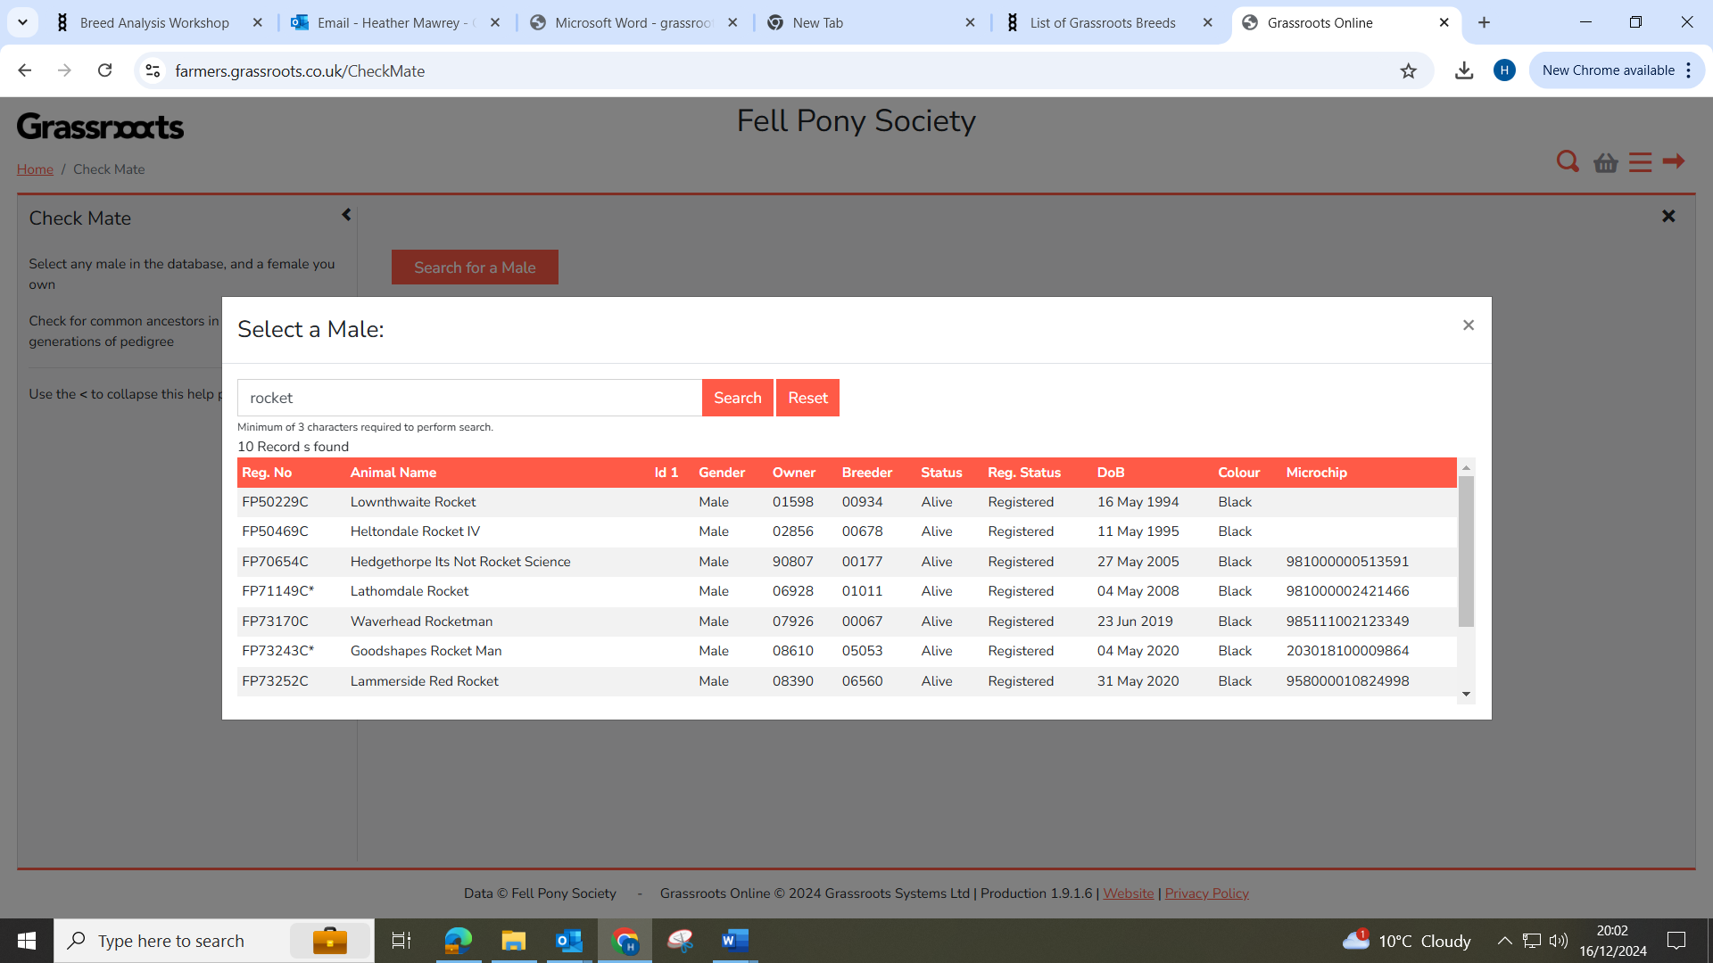
Click on Search for one of my females for a list of alive females in your registered ownership. Select the animal from the list offered. | 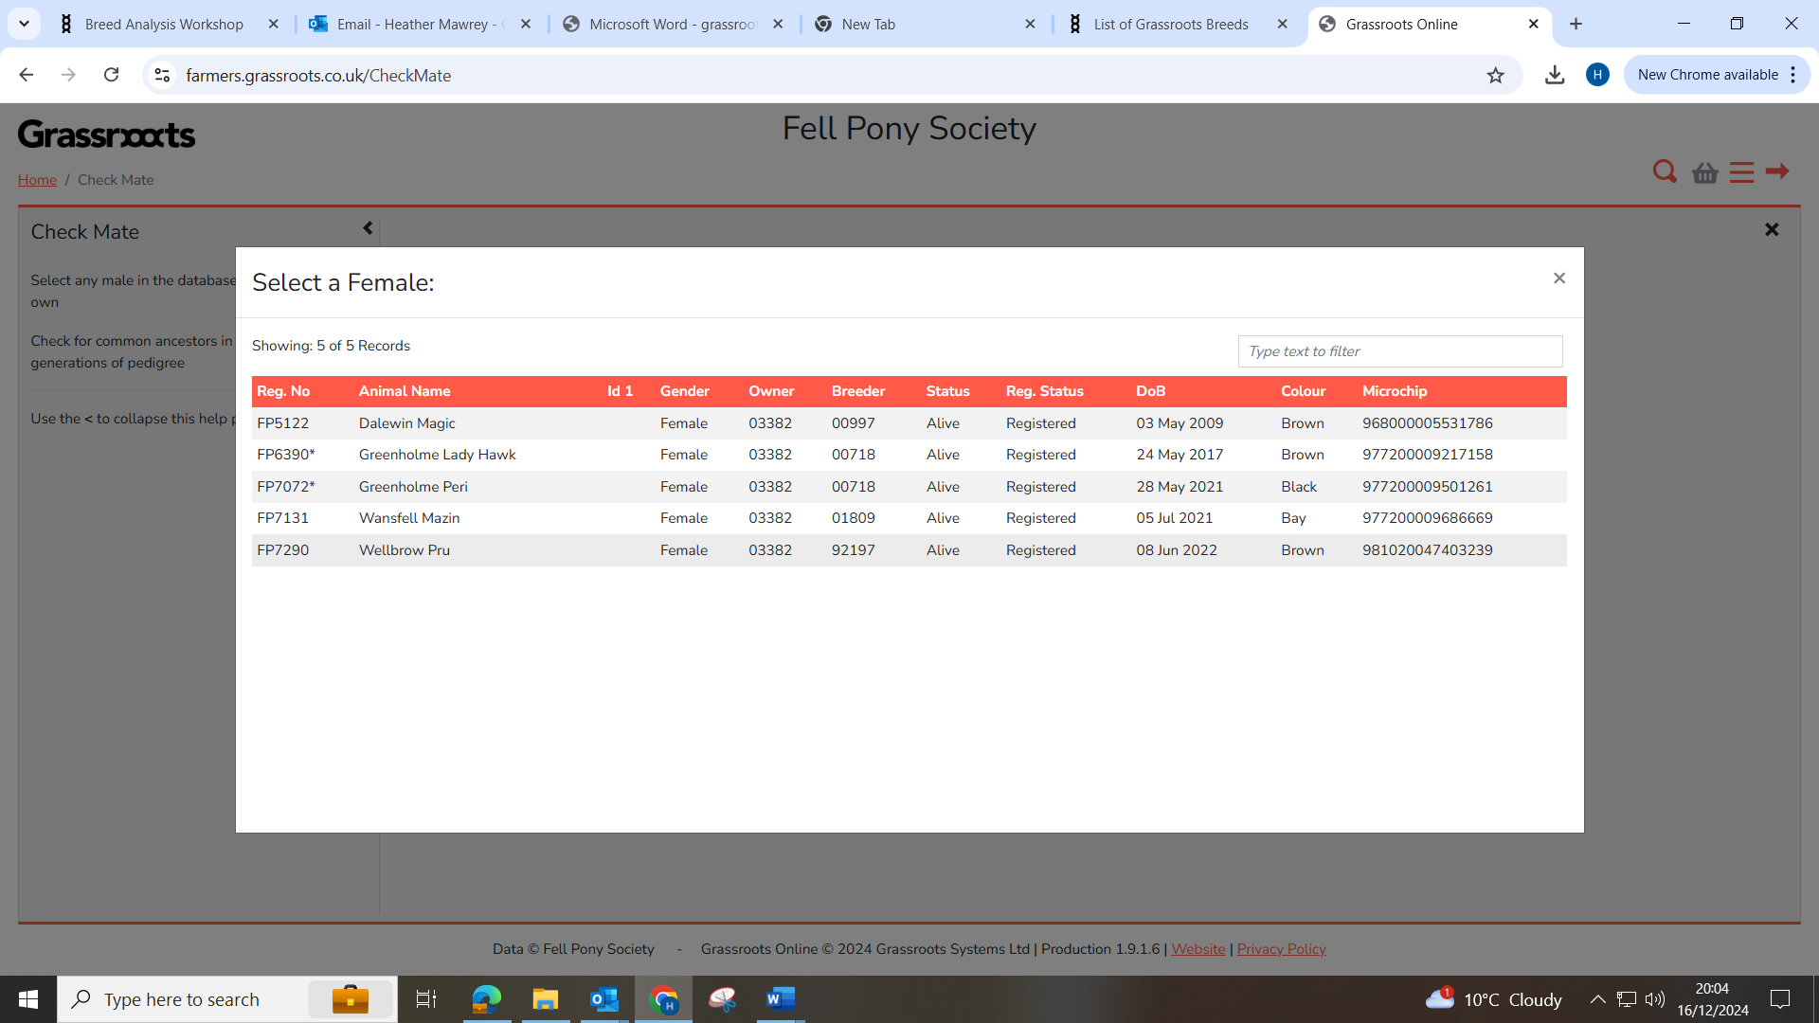
The ‘What if’ pedigree will be displayed with common ancestors in colour. Red – indicates a common ancestor that first appears as a parent or grandparent. Yellow - indicates a common ancestor that first appears as a great grandparent. Green - indicates a common ancestor that first appears as a great great grandparent. | 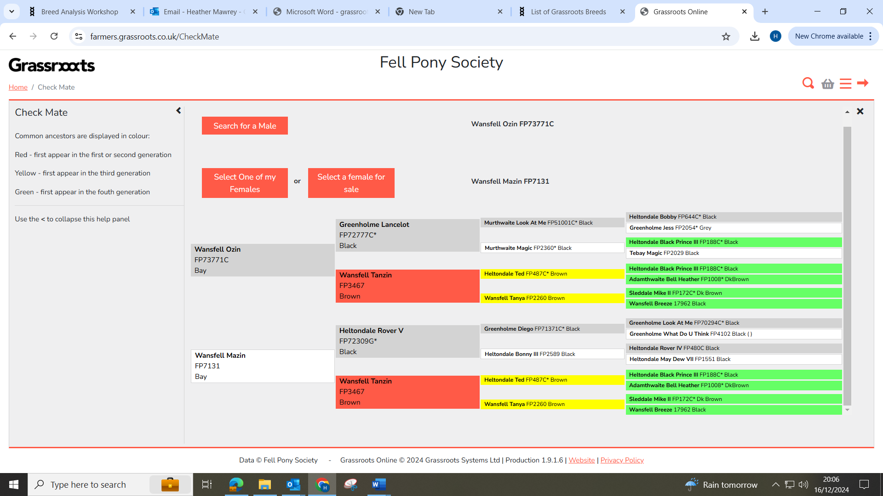
No colour indicates no common ancestors for four generations. | 