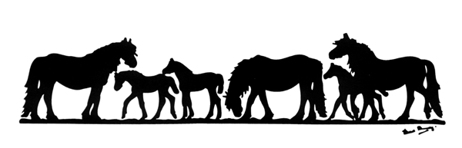

APPLICATION FOR STALLION A.I. PERMIT

The Secretary, The Fell Pony Society, Bank House, Boroughgate, Appleby, Cumbria CA16 6XF

Please complete this form clearly in BLOCK CAPITALS

I hereby acknowledge that I have read and agree to be bound and abide by all the Fell Pony Society current guidelines established for Artificial Insemination. I also understand that non-compliance with these guidelines will be reviewed by the FPS Council.

I acknowledge that the Fell Pony Society will not be held responsible and will be free of liability in all cases of Artificial Insemination, any representation, agreements or guarantees between any and all parties involved.

I confirm that I am a Member of the Fell Pony Society and enclose the current fee, £25 for a life permit.

* * * * * * *

Name of Stallion:……………………………………………………………………………………………………
Reg No:………………….……………………. Lic No:…………….……… Date of Birth:………………………
Colour and Markings:………………………………………….……………………………………………………
…………………………………………………………… Microchip No:…………………………………………
Sire:…………………………………………………………………… Reg No:…………………………………….
Dam:…………………………………………………………………... Reg No:…………………………………….

Name of Owner(s)/Lessee:…………………………………………………………………………………………
Address:……………………………………………………………………………………………………………….
………………………………………………………………………………. Postcode:……………………………
Date:………………………… Signature of Owner(s)/Lessee:…………………………………………………

For Office Use Only

Permit No Issued:…………………………………………………………… Date:……………………………

A Company Limited by Guarantee. Company Number 3233346

Registered Charity Number 1104945

