“HORSE TALK”

Tues 2nd March 2010

7.30pm Soulby Village Hall Nr. Kirkby Stephen

£4.00 including refreshments

Chairperson – Lesley Adamson (vet)
Dr Susan Heywood - Grass Sickness
David & Alison Roper – “Taking us a ride along the Pennine Bridleway”
Sam Galloway (vet) - "Atypical Myopathy - an emerging threat?"
Paul May (vet) –isolation of gene responsible for Fell Pony Syndrome

And

Ask the Experts
Your chance to put your horsey questions to the panel

ALL WELCOME

For more details contact: Hilary Fawcett Tel. 01768341417 or Ellen Jones 01768483511 Organised jointly by:
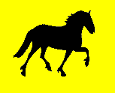 The Cumbria Dales Pony Society Area Group & 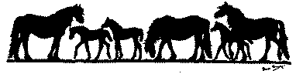
The Fell Pony North West Area Support Group

