The Story of the Centenary Scarf
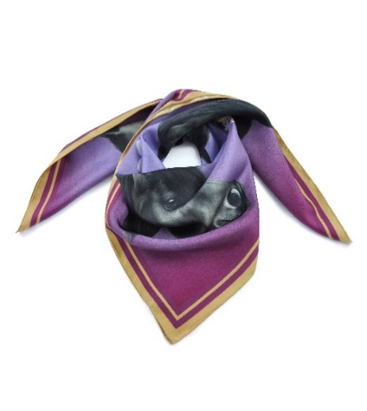

As part of The Fell Pony Society’s Centenary Celebrations we want to say thank you to our Patron Her Majesty The Queen. When we think of her connections with Fell Ponies we are reminded of beautiful photos of her riding her Fell ponies in the grounds of Windsor Castle, wearing her iconic headscarf. It seemed only fitting that a personal gift of a headscarf should be produced for her by a British Printer, designed by a Native Pony Artist on behalf of The Fell Pony Society. The development of the scarf has taken some 18 months of hard work from initial idea to production and we wanted to share a little bit of the history.

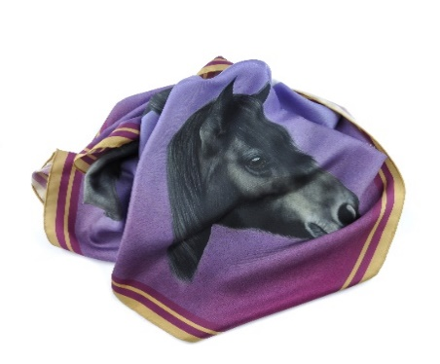
Artist : Laura Pennell : Creating “The Flower of Cumbria”
laura-pennell.co.uk
Dales and Fell ponies have long had an entwined history for me. My family breed Nipna Dales ponies and we have a strong affinity with the Fell pony, we have owned Fell Ponies from a variety of studs.
I have been working as a professional pastel pencil artist across the last 4 years. About 18 months ago we started discussing what the scarf should look like, going through various options and motifs before settling on using an image of the Queen’s own pony, Carltonlima Emma. We approached Bob Langrish, renowned photographer, who had photographed Emma for use in the Breyer model Fell pony. He very kindly gave us permission to use his photos. We decided on using a colour palette that would reflect the Queen’s racing colours – so my background became a lilac blended into scarlet to emulate them. As well as including the Fell Pony Society Centenary logo, we also wanted to include a decorative element to add interest to the scarf and chose the flower of the grass of Parnassus. This small white flower is known as the ‘flower of Cumbria’, which seemed highly appropriate to connect to the pride of Cumbria, the Fell Pony. With discussion from the scarf printer Samuel Petty, founder of David Watson silk printers, the final touch was to include a double band of gold round the edging of the scarf, which tied in with the Queen’s racing colours and gave the scarf a luxurious, very special finish.
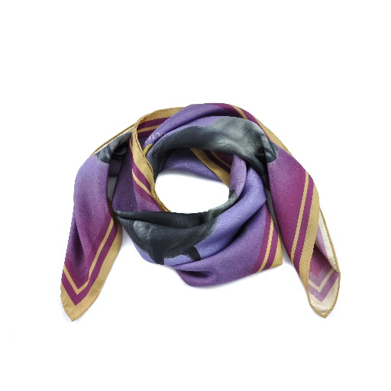
The Printer : Samuel Petty, Creative Director from David Watson silk printers
davidwatson.uk
David Watson collaborates with British artists and shares their designs on fashion accessories and cushions. Our silk scarves are printed, and hand finished in Worcestershire. We are honoured to have worked with The Fell Pony Society to commemorate their 100 year anniversary and create a unique gift for their Patron. I was very pleased to be involved as I have a soft spot for all things native pony living in the New Forest and being involved in commoning there.

Thank You & Sharing the Celebrations
The creation of the scarf has been a hugely collaborative effort and The Fell Pony Society would like to thank Laura Pennell, Samuel Petty, Bob Langrish and to all members of the Centenary committee for their input.

Having presented Her Majesty, The Queen with her personal gift at Royal Windsor Horse Show, we wanted to share in the Centenary Celebrations and asked David Watson and Laura Pennell if they would allow The Fell Pony Society to produce a small number of limited edition head scarves. These will be available to order direct from The Fell Pony Society office. They will retail at a special price of £100 plus postage and package and payment is to be made up front to The Fell Pony Society. We expect there to be approximately a 4 week lead time whilst David Watson produces a further limited edition range of these beautiful scarves.
Jane Rawden
Centenary Committee Chair, The Fell Pony Society.

