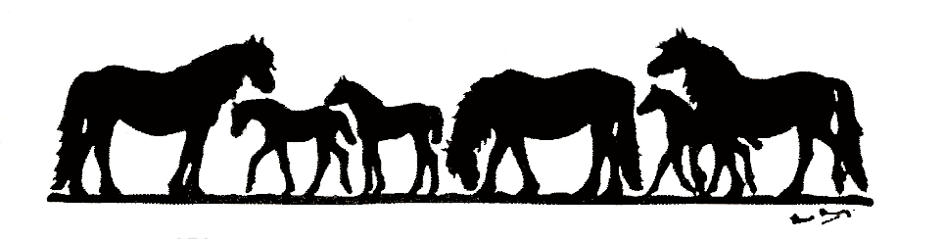
THE FELL PONY SOCIETY

COVID-19 Protocol

Mares/Stallions travelling to Studs

Please read the protocol on transporting Fell Ponies during lockdown which you can download from the Society website www.fellponysociety.org.uk Please print this form, complete it and ensure it accompanies the mare/stallion to the stud. By signing beneath you are confirming that you have read and are complying with the Fell Pony Society Covid -19 protocol.

Stud (name and address) .. ……………………………………………………………………….

…………………………………………………………………………………………………………………..

Owner Name of Stallion/Mare (travelling) …………………………………………………

Owner Signature of Stallion/Mare (travelling) ……………………………………………..

Date and time of booked covering ………………………………………………………………………

Name of mare(s) to be covered …………………………………………………………………………

Name of transporter and vehicle registration number ……………………………………………….

…………………………………………………………………………………………………………………..

Name of driver ………………………………………. Signature of driver ……………………………….

In case of non-compliance with the above instruction, or in case of doubt, the Owner of the Stud can refuse to accept the mare(s)/stallion.

