Bootle Pleasure Ride
Sunday 22nd April 2018

Organised by the Fell Pony Society Promotions Team
Raising funds for the Promotions Team funds
Venue: Millstones, Bottle, LA19 5TJ

Class 1. 5km Class 2. 8/10km
Class 1 suitable for lead rein and disabled riders

Meet 10am for instructions Ride leaves 11am
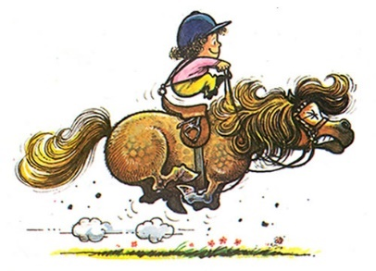
The ride shall be followed by tea/coffee and home baking.

Entry Fees: £15 per pony or £12 for lead rein ponies

Entries will be limited. Children under 12 must be accompanied by an adult.
All participants must have 3rd party liability insurance.
Correctly secured Skull Caps/Riding Hats that meet the current Safety Standards/specifications MUST be worn by all riders of all ages.
Entry form & rules are on The Fell Pony Society website and Fell Pony Society Promotions Team Facebook page.
For more information contact Susan Brunskill 07765508608
or Kath Ellis 07729804405

